Churton Neighbourhood Plan – Initial Consultation
The purpose of this document is to help the CNP Planning Group to understand how the Churton Community feel about the future of the village.
We need to know
- What local people feel are the benefits and desirable features of the village.
- Which Green Spaces should be protected within the village boundaries and nearby?
- What “Heritage” we should be careful to conserve.
- What issues raise concerns for the village
- What future housing requirements the local people feel may be desirable or needed.
For the purposes of this initial Consultation, we ask you to anonymously give us some details about you & your immediate family, this will help us understand the demographic build up of people in the village.
Please leave blank any question you may think invasive or are reluctant to answer.
Please add any comments which you think relevant or helpful to our understanding.
To make it easy to return your questionnaire you can drop off (or post if you prefer) the completed form in the envelope provided to any of the addresses below:
Church House, Church Mead, Pump Lane, Churton, CH3 6LR
Quarry Cottage, Stannage Lane, Churton, CH3 6LE
Churton Mount, Hob Lane, Churton, CH3 6JZ
If you would like someone to collect your completed questionnaire, please phone or text 07831 487090
If you prefer to complete the questionnaire electronically you can download it as a Word document from the Parish website https://cheshireparishcouncils.co.uk/welcome/churton-parish-council/churton-parish-council-news-events/ it can then be submitted using this email address churtonparishclerk@hotmail.co.uk You can also scan your questionnaire and send it to this email address.

Part 1 – You and your current accommodation.

Please indicate the number of people in your household (include members of the family who may be in full time education away from home) within each age range:
Sixty Plus………………………………..
45 to 59 …………………………………
30 to 45………………………………….
18 to 30………………………………….
11 to 17………………………………….
5 to 10…………………………………….
Under 5…………………………………...

Your Home is: (cross-out the ones that don’t apply)
Detached house/Semi-detached house/Bungalow/Terraced House/Adapted/Other?
Tenure: (cross-out the ones that don’t apply)
Owner Occupied/rental/Work-place tied housing/Multiple Occupancy
Employment-Transport (please indicate all that apply)
How many in your household?

Work-from-home travel <10 miles to work/school travel >10 miles to work/school
Part 2 – Churtons Special Features (A plan of the Parish boundary is included on the last page)
What do you like most about Churton? (Please add any additional special features we should include)
- Size?
- Location to Chester?
- Rural look & Feel?
- Safe Environment?
- Quiet?
- Location to Schooling?
- ………………………………………………………………………………………………………….
- ………………………………………………………………………………………………………….
What should the Neighbourhood Plan Protect?
Please rank these from 1 -10 where 10 is very important and 1 is least important
  - Views & Vista’s?
  - The Old Pump?
  - The White Horse?
  - Village hall?
  - Existing buildings?
  - Green Spaces?
  - Trees & Hedgerows?
What concerns do you have regarding Churtons future evolution?

Part 3 – Future Needs & Development

Do you or your immediate family need different /alternative housing? (5 year +)
Larger?
Smaller?
Single story?
Adapted?

What should we desire of future developments? (Please add any extra items you would like to see)
More affordable housing?
(The term affordable housing has a specific meaning with
regards to planning, a definition is included overleaf)
Older Persons accommodation?
New Sports or recreational developments?

Please make any further comments you feel may be helpful

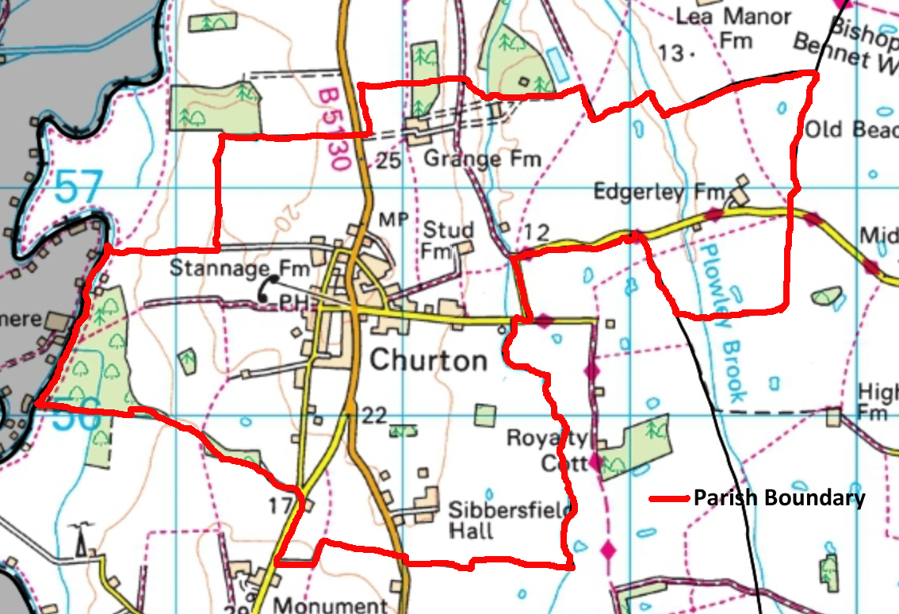
Churton Parish Boundary
Definition of Affordable Housing
MHCLG - National Planning Policy Framework - CP 48, Annex 2 – Glossary
Affordable housing: housing for sale or rent, for those whose needs are not met by the market (including housing that provides a subsidised route to home ownership and/or is for essential local workers); and which complies with one or more of the following definitions:
a) Affordable housing for rent: meets all of the following conditions: (a) the rent is set in accordance with the Government’s rent policy for Social Rent or Affordable Rent, or is at least 20% below local market rents (including service charges where applicable); (b) the landlord is a registered provider, except where it is included as part of a Build to Rent scheme (in which case the landlord need not be a registered provider); and (c) it includes provisions to remain at an affordable price for future eligible households, or for the subsidy to be recycled for alternative affordable housing provision. For Build to Rent schemes affordable housing for rent is expected to be the normal form of affordable housing provision (and, in this context, is known as Affordable Private Rent).
b) Starter homes: is as specified in Sections 2 and 3 of the Housing and Planning Act 2016 and any secondary legislation made under these sections. The definition of a starter home should reflect the meaning set out in statute and any such secondary legislation at the time of plan-preparation or decision-making. Where secondary legislation has the effect of limiting a household’s eligibility to purchase a starter home to those with a particular maximum level of household income, those restrictions should be used.
c) Discounted market sales housing: is that sold at a discount of at least 20% below local market value. Eligibility is determined with regard to local incomes and local house prices. Provisions should be in place to ensure housing remains at a discount for future eligible households.
d) Other affordable routes to home ownership: is housing provided for sale that provides a route to ownership for those who could not achieve home ownership through the market. It includes shared ownership, relevant equity loans, other low cost homes for sale (at a price equivalent to at least 20% below local market value) and rent to buy (which includes a period of intermediate rent). Where public grant funding is provided, there should be provisions for the homes to remain at an affordable price for future eligible households, or for any receipts to be recycled for alternative affordable housing provision, or refunded to Government or the relevant authority specified in the funding agreement.

